Table of contents
Preamble 6
A few definitions 7
Summary 9
1. Description of leading market players 18
1.1. Fixed instant messaging services 18
1.2. Mobile instant messaging services 20
1.3. Panorama of the instant messaging market in 2003 21
1.3.1. Three major providers dominate the French and world fixed IM services market 21
1.3.2. Corporate market looks promising 23
1.3.3. Mobile service operators develop specific value-added services 25
2. How instant messaging solutions work 27
2.1. Introduction 27
2.1.1. Concept 27
2.1.2. General approach and common elements 27
2.1.3. Transposing these models into fixed and mobile networks 30
3. Business models related to instant messaging services 35
3.1. Case of fixed service providers 35
3.1.1. Independent instant messaging service providers 35
3.2. ISPs offering instant messaging services 39
3.3. Case of mobile service providers 43
3.3.1. Mobile chat services 44
3.3.2. Access to fixed instant messaging services on mobile terminals (SMS, J2ME) 46
3.3.3. Conceivable value chain in the case of mobile instant messaging services 48
3.3.4. Examples of instant messaging services launched abroad 50
3.4. Solution providers offering corporate instant messaging services 52
3.5. Synthesis 56
3.5.1. Towards the deployment of convergent services? 56
3.5.2. Which change factors would allow fixed and mobile value chains to move closer together? 57
4. Service development prospects 59
4.1. Interoperability 59
4.2. Voice over IP and Video over IP services 65
4.3. Peer-to-peer 70
Annex 1: Acronyms and definitions 74
Annex 2: List of interviewed companies 76

Table of illustrations

Tables
Table 1: Description of several IM solutions 19
Table 2: Leading instant messaging applications and embedded features, March 2003 22
Table 3: Interoperability of leading instant messaging applications, March 2003 23
Table 4: Asynchronous, synchronous and integrated collaborative work solutions 24
Table 5: Coming collaborative work solutions 24
Table 6: General description of the leading consumer instant messaging systems 31
Table 7: General description of the leading consumer instant messaging clients’ functions 32
Table 8: General description of the leading consumer IM systems’ value chains 37
Table 9: General description of the leading consumer IM systems’ value chains 38
Table 10: General description of the leading consumer IM systems’ value chains 41
Table 11: General description of the leading consumer IM systems’ value chains 42
Table 12: Description of mobile chat offers in France 43
Table 13: Price of Vodafone UK’s and Orange UK’s services 51

Figures
Figure 1: General instant messaging services value chain 10
Figure 2: Fixed instant messaging services value chain 10
Figure 3: Mobile instant messaging services value chain 10
Figure 4: Hybrid peer-to-peer model 11
Figure 5: Client/Server model 12
Figure 6: Client/Server model 28
Figure 7: Hybrid Peer-to-Peer model 29
Figure 8: Fixed networks' case, Hybrid Peer-To-Peer model 30
Figure 9: Mobile networks' case, Client/Server model 33
Figure 10: Value chain of leading IM service providers 35
Figure 11: 1st generation fixed IM services 39
Figure 12: Value chain of leading ISPs providing IM services 40
Figure 13: Mobile chat services 44
Figure 14: Value chain of mobile chat services 45
Figure 15: Access to fixed instant messaging services on mobile terminals (SMS, J2ME) 46
Figure 16: Value chain of access to fixed instant messaging services on mobile terminals (SMS, J2ME) 47
Figure 17: Coming mobile IM services 48
Figure 18: Case of an instant messaging solution that interoperates with other mobile operators and / or fixed IM providers 49
Figure 19: Screenshots of O2 Germany’s ICQ service 50
Figure 20: Sending a message 51
Figure 21: Value chain of instant messaging solutions in the business market 52
Figure 22: Various Bantu IM clients 53
Figure 23: Diagram showing the interoperability of FaceTime’s solution 54
Figure 24: Architecture of the FaceTime IM Director Development Platform 54
Figure 25: General architecture of the IM Manager solution 55
Figure 26: Trillian user interface 62
Figure 27: Odigo user interface 63
Figure 28: The VoIP service provider value chain 65
Figure 29: MSN Messenger 6.0 telephony over IP interface 66
Figure 30: The AIMPhone Interface 67
Figure 31: Skype interface 70
Figure 32: Skype's VoIP service compared to those provided by other VoIP specialists or IM services providers 71

Preamble

ART wished to be informed of the challenges related to the development of instant messaging in fixed and mobile environments. They set the following main objectives for the “study relating to instant messaging services” that we conducted:
- To describe the different instant messaging systems in fixed and mobile environments
- To identify gateways that exist between the various systems currently available
- To examine interoperability challenges and the prospects for interoperability between the different solutions
- To specify who the key players are in the various fixed and mobile value chains
- To specify the related business models
- To describe the underlying competitive challenges
- To analyse the prospects for growth and for combining instant messaging with other services in terms of usage
- To comment upon change factors that may emerge in this context through the analysis of the evolution of the value chain and the evolution of business models.

A few definitions

Buddy List: A list of contacts defined by a user on the basis of criteria of quality (common interests, community member…).

Chat: Service allowing a user to send messages to a mailing list in real time. The mail list corresponds to one or several chat rooms.

Chat room: A discussion room.

Client: Software application enabling access to information in a server. Examples of clients include: web browsers, messaging utilities, chat utilities… The reader should be aware of the difference between “user” and “client” (software) throughout the rest of this report.

Instant messaging: An instant messaging (IM or IMing) service is characterised by the use of specific software that adds the notions of presence and buddy list to the notion of chat.

Open Source: Software with open-access source files.

Peer-To-Peer: an internet-based file sharing, exchange and computing system enabling PC web users to communicate directly with each other without using a server as a relay to transfer information. (e.g.: downloading music in MP3...).

Presence: The presence function in software enables use of information concerning service users’ status (offline, online, busy, present in a geographic area, availability on another terminal…).

Streaming: The continuous delivery of audio and video content as files are downloaded.

Abstract

Summary

Study context

This report aims to shed light on the challenges related to the development of instant messaging (IM) in fixed and mobile environments. French users currently have access to PC-based instant messaging services, but mobile-based services are not yet available. A number of solutions for using these services on mobile networks can be found abroad, ranging from the basic sending and receiving of an SMS to the use of dedicated software, as in the fixed sector.
These services are enjoying increasing success and are getting ready to penetrate the business user market.

Characteristics of instant messaging services

In 2003, instant messaging services combine all the features currently available in the person-to-person communication sphere:

- Instantaneous communication
- Ability to set up voice and text-based calls
- Ability to set up video calls
- Ability to exchange data files
- Ability to leave messages for absent users in a mail box

A vital addition to these features is information regarding the status of the instant messaging service user. If this person is away, or is not using his/her connection utility, all the other users are informed in real time before they try to establish a connection.

This feature gives the service its own unique character and positions instant messaging services as truly convergent services, offering their users the whole array of interpersonal communication services that are currently available on voice telephony and internet networks.

Players involved

There are numerous links in the instant messaging services value chain:
Figure 1: General instant messaging services value chain


Source: IDATE

The main players in each link are positioned differently depending on whether they are active in the fixed or mobile service sectors.

Case of fixed services

In this case, software solution developers and service providers often play the same role since fixed instant messaging services were developed by the leading providers of services currently available on the market.
Likewise, certain access providers have also developed software solutions which correspond to the services that they offer their customers.
Figure 2: Fixed instant messaging services value chain
Source: IDATE

Case of mobile services

In this case, the value chain is still fully integrated, with access providers (mobile operators) also playing the role of service providers, and mobile handset providers acting as software solution developers, system integrators, handset OS providers, and equipment providers.

Figure 3: Mobile instant messaging services value chain
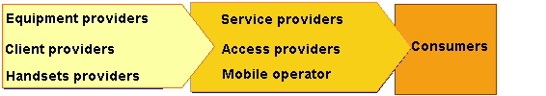Source: IDATE

Technologies implemented

All the technologies used by leading service providers are still mostly based on proprietary standards which they themselves have developed. The fact that the majority of these providers are migrating their applications to common SIP-based communication protocols is nevertheless worthy of note.

In practice, instant messaging services are based on two types of equipment:

- Instant messaging clients, which take the form of software installed on access terminals, which act as user interfaces. These clients currently use the TCP protocol to send and receive a stream of data, which is exchanged in peer-to-peer (P2P) mode by clients in the fixed segment and by SMSes in the mobile segment.
- Addressing and presence servers, on which users register the first time that their client logs on. After this initial operation, these servers manage users’ presence information, in other words, their availability status (online and active / online and inactive / offline).

Figure 4: Hybrid peer-to-peer model
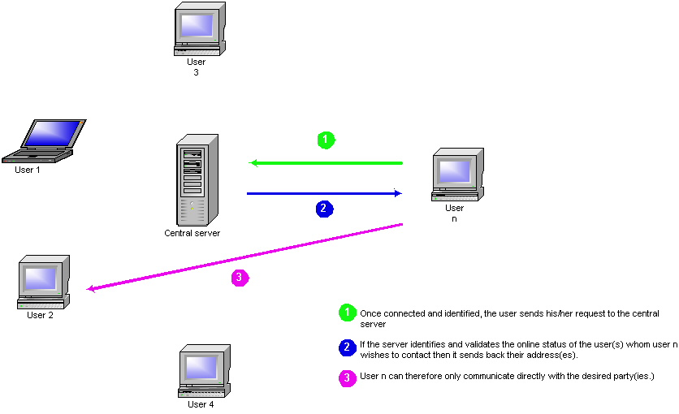

Source: IDATE

More often than not, in the fixed services area, these tools are implemented in a “hybrid peer-to-peer” model (figure 1), wherein calls do not pass through a server, but are exchanged from client to client, or in a “client-server” model, wherein this same stream of data passes through a content server.

When fixed services include gateways with functions linked to the mobile environment, these functions are built into the instant messaging clients.

Furthermore, the “ client-server” model is systematically implemented in the case of mobile operators’ service offerings.

Figure 5: Client/Server model
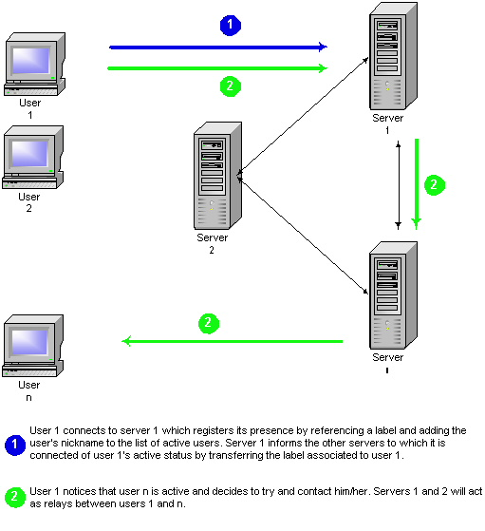
Source: IDATE

Business models implemented

Fixed and mobile instant messaging services are not at the same stage of development, since fixed IM services were introduced a great deal earlier by companies such as MSN, AOL and Yahoo! than in the mobile industry, where these services are still in their infancy.

Fixed instant messaging services are provided free of charge to internet users at present. Major market players are starting to charge for value-added services as the penetration rate of instant messaging increases and as they win their users’ loyalty. Nevertheless, at the end of 2003, revenues related to the sale of advertising space on IM clients still constitute their largest source of income, and are occasionally instant messaging service providers’ only source of revenue.

In the mobile sector, instant messaging services are billed on a pay-per-use basis, based chiefly on the price of a sent or received SMS, depending on the case, even though SMS is not the direct means of transport. Subscription to the service may or may not be free, and – as in the fixed sector – the user pays his/her access operator a flat rate for access to the internet.

These differences are a major hindrance to the development of convergent services. Although the adoption of SIP-based architecture seems inevitable in both the fixed and mobile sectors, the convergence of fixed and mobile business models appears unlikely. Furthermore, the mobile industry will have to add equipment to its network architecture, since a Presence Management Server is required to provide mobile SIP-based IM services.

Value-enhancement strategies

The development of instant messaging appears to be conditioned by various factors, depending on whether fixed or mobile services are involved.

In the fixed sector, offers have been available for a sufficiently long time for usage to develop around online communities. Service providers therefore face a two-pronged problem:
- In those countries where IM services have not achieved a high rate of penetration, service providers are developing a strategy aimed at attracting new users to their own clients, which are free,
- In those countries where IM services have reached a significant rate of penetration, service providers have adopted a strategy skewed towards value creation: customers are now starting to be charged for certain value-added services in this case.
In each of these cases, service providers are aiming to develop a sizeable user community, in terms of number of subscribers, to which they can introduce value-added interpersonal communication services.

Service providers face a different problem in the mobile sector: introducing services based on sending text messages which compete with established and revenue-generating types of use, such as sending and receiving SMSes. Development of usage will be based on pay-per-go from the outset, meaning that instant messaging services could grow at a slower rate. In addition, this is not a fixed paid business model, and may, perhaps, evolve partly towards a free model so as to facilitate the convergence of fixed and mobile IM communities in particular.

Change factors

Certain change factors could speed up and encourage IM adoption. Among these are:

- Corporate users’ adoption of platforms based on the Microsoft Realtime Communication Server (Microsoft Exchange server, Office 2003): these solutions put instant messaging at the heart of the enterprise by developing the principles of collaborative work. Consequently, use of instant messaging services within the enterprise is likely to develop, thereby encouraging the adoption of this same service among consumer customers. Added to this, people with office suites for home use will, of course, have instant messaging tools built into their software.
- Adoption by mobile handset users’ with an open operating system: use of these handsets will allow mobile users to choose and install applications themselves, and to use services provided by players other than mobile operators. This could have a significant impact on the mobile services value chain, insofar as the “openness” of these terminals removes one of mobile operators’ control points in the value chain, that of users’ access to the client enabling them to use the operator’s services.

Interoperability

Interoperability between instant messaging systems is inexistent at present in the fixed services sphere and an important element in the development of the mobile services market. It looks as though it will be difficult to change this situation and progress towards full interoperability between fixed and mobile services given the following major constraints:

- Interoperability may lead to the convergence of revenue-generating models. In this case, it is difficult to evaluate the model towards which these players might converge since pay-per-use billing in the mobile sector and an entirely model in the fixed sector seem incompatible at present.
- In the fixed sector, the “entirely free” model that was put into place for major service providers has led these players to try and maximise their user base in such a way as to increase their advertising revenues. This logic has not had a positive impact on these providers’ advertising income insofar as these players have a “captive” subscriber base, in other words entirely dependent on the provider.
- Interoperability between IM services is imperative in the mobile sector since these services are fee-paying. However, mobile interoperability is not synonymous with the convergence of business models adopted by various mobile operators and will thus require case-by-case commercial agreements between these different players (creation of a clearing house…).

VoIP services

Major market players provide VoIP-type services for instant messaging service users. Most IM software clients have audio compression codecs enabling them to support VoIP services. Instant messaging is a communication tool that is relatively well suited to the development of this type of service, for numerous reasons:
- The problem of the directory, which is very important in the VoIP service field, is solved by the instant messaging client’s automated management of a buddy list through the presence function;
- The problem of the software for accessing VoIP services, which is distributed naturally by ISPs or accessible via free downloads.
In addition, VoIP services have recently appeared directly in the P2P world with the launch of Skype by the founders of the file-swapping software Kazaa based on Fastrack technology.
Nevertheless, VoIP services via IM clients do not yet ensure full continuity of service with PSTN or mobile subscribers since phone subscriber have no visibility of VoIP users. The call can only be initiated in the fixed IP environment, the call going out to PSTN or mobile phone subscribers. This one-sided call initiation constraint is one of the service’s prime limitations.

Development scenarios

We think that instant messaging services look set to develop on a large scale in the future, in accordance with a 3-stage scenario:

- First stage: "User group development"
Various telecommunication service user populations will see instant messaging services appear in the range of services available to them over the course of this period. Instant messaging is combined with email in fixed-line business communities and instant messaging services gradually emerge in all of operators’ offerings in mobile user communities. These services are interconnected and specific clients are available on the web for mobile service providers’ users who would like to use their PC.

- Second stage: "Development of usage"
This stage marks the development of instant messaging service usage by the various user categories, of which certain sub-segments start to use paid value-added services. In particular, users of fixed-line IM services begin to use voice services on a regular basis: in some businesses from workstation-to-workstation, and in the consumer segment, to call other users at the cheapest price. Growth of voice calls increases as instant messaging services become more popular. IM clients rapidly become the number one software client used by onliners for Voice over IP services. On this occasion, we start to see a link being formed, especially with PSTN subscribers and mobile networks. VoIP services via IM clients allowing PSTN or mobile subscribers to terminate calls are available in the States through players like AOL or MSN, for instance.
In the mobile sector, the number of Wireless Village-compatible open OS terminals starts to grow. We begin to see the first trials being conducted on the presence function, which operators manage at level of their network, for these devices (presence management servers). This suggests, therefore, that IM client providers and network operators may come together to guarantee improved interoperability.
Fixed and mobile communities are still separate at this stage.

- Third stage: "Universality"
In this third stage, fixed user communities have developed on a sufficiently large scale to erase the club effect and to enable IMing to be considered as an essential service by a large portion of telecommunication service users. Service providers agree to interconnect by offering their users the ability to pay a flat rate to finance this universitality.
Access to universal messaging services in the mobile sector will take place in two stages: first, interoperability between the various mobile service providers, then with fixed service providers. At this stage, presence functions are widespread and are combined with location functions in numerous cases.
Access to this universal instant messaging service might be provided for a fee.

* *
*

Instant messaging services:
analysis and challenges

Description of leading market players

Instant messaging services combine access to a service allowing messages to be sent and received instantly and access to a list of contacts created by the user, whose availability is specified by the service access tools. There are several types of services.

Fixed instant messaging services

These are the most numerous services. They can generally be accessed through specific software, called clients, which can usually be accessed free of charge. After registration, these software allow users to exchange messages, mostly plain text, in real time.

The major names in the industry are MSN, with its client MSN Messenger, AOL, with AOL Instant Messaging, Yahoo!, with Yahoo! Messenger, then ISP offerings (Wanadoo Messager, from Wanadoo, Tom, from T-Online, Tiscali Messenger, from Tiscali). There are several player categories in the instant messaging service world:

Telecom infrastructure provider: this is the operator of the IP network that carries the traffic. This operator, which controls the physical client access network, gives the service provider the connectivity that it uses.

IP access provider: this is the provider of IP connectivity. This player provides the user with the ability to connect his/her terminal to the internet by providing his/her equipment with an IP address. In practice, this player uses the telecom infrastructure provider’s physical resources and allows its users to use instant messaging services offered by service providers.

Instant messaging service provider: this is the company that controls access to the list of potential message recipients. This company provides access in the form of an internet service, which is free at present, more often than not.

Instant messaging client provider: this is the company that designs and distributes the software allowing users to access instant messaging services. Service providers and client providers are generally linked together, as the protocols used are proprietary most of the time.

Instant messaging service users: these people may be home web users who will have downloaded clients to use them, businesses, who will offer their employees the ability to use these services, or advertising professionals, who will use the advertising space available on instant messaging clients to sell them to advertisers.

These five player categories may or may not be separate in the fixed instant messaging world, and express themselves in consumer service or business service environments.

Table 1: Description of several IM solutions
Instant messaging service | Telecom infrastructure provider | Internet access provider | Instant messaging service provider | Client provider | Users
MSN Messenger | Free, chosen by the internet access provider | Free, chosen by the customer | MSN | Microsoft | Consumers
AOL Instant Messenger | Free, chosen by the internet access provider | Free, chosen by the customer | AOL | AOL | Consumers / Corporate
Yahoo! Messenger | Free, chosen by the internet access provider | Free, chosen by the customer | Yahoo! | Yahoo! | Consumers
Messager wanadoo | Free, chosen by the internet access provider | Wanadoo | Wanadoo | Wanadoo | Consumers
T-online "TOM" | Free, chosen by the internet access provider | T-Online  (Club-Internet in France) | T-Online  (Club-Internet in France) | T-Online  (Club-Internet in France) | Consumers
Tiscali Messenger | Free, chosen by the internet access provider | Tiscali | Tiscali | Tiscali | Consumers
Source: IDATE

Mobile instant messaging services

As yet few in number, these services still constitute a real field of experimentation for most mobile service operators to date. As they do not enjoy widespread distribution, these services are based on the same operating features as wireline services. However, in the case of mobiles, users are charged for messages sent and / or received, as well as having to pay for access to the service in certain cases.
The infrastructure, access and service provider are very often one and the same player in this sphere. In a great many cases, these three roles are played by the mobile operator. In practice, therefore, the leading market players are:

- Mobile operators: they provide users with access to the service, which they generally manage as well. They charge service users for messages received and sent on the basis of a price schedule which they themselves set. In most cases, they also manage the instant messaging services that they offer, with a very few exceptions, where mobile operators refer to certain third party providers’ services.

- Client providers: they provide mobile operators with the clients embedded in mobile handsets that they market to their service users. In the majority of cases, these players are handset manufacturers, but not always, as the advent of mobile terminals with so-called “open” OSes (because applications can be installed on them after they have been purchased) is altering market access conditions for independent providers.

In the case of these services, operators act as ISPs and instant messaging service providers. These services could be implemented by integrating various technical solutions:

- By using the sending and receiving of SMS and MMS messages from a software client present on the subscriber’s terminal,
- By using the sending of XML frames (XMPP) over a TCP/IP session in GPRS mode (it would be possible to charge for each frame or message in this case),
- By using SIP over IP sessions, also established over a GPRS session (each frame will be billed in this case too).

These services are geared towards consumers. The mobile instant messaging service market for business customers has not developed yet.

Panorama of the instant messaging market in 2003

Instant messaging services have developed in each of the fixed and mobile spheres. However, they are in a more or less advanced state of development, depending on the case.

We therefore find:
- On the one hand, chat services, which can generally be accessed on portals and constitute closed communities of users exchanging thematic messages. These services are deployed on a very wide scale, on LANs in the business world, and also through ISP, web service provider and mobile service provider portals for consumers. They are not, strictly speaking, instant messaging services (because information related to user presence is not available), but foreshadow them.

- On the other hand, instant messaging services per se, which use dedicated applications integrating presence notification or even file sharing features, as described above.

Three major providers dominate the French and world fixed IM services market

On the consumer application side of things, three major providers offer solutions that dominate the public IM market in metropolitan France and the rest of the world. First come the solutions offered by AOL, which developed very swiftly in the United States and helped establish a form of community identity associated more with "America Online" than with the internet. AOL offers two major solutions, AOL Instant Messaging (which now enables short messages and files to be exchanged, incorporates web browser tools and agenda management capabilities, etc.) and ICQ, developed initially by the company Mirabilis, whose 2002 version follows in Microsoft Outlook’s footsteps by sporting a built-in POP/SMTP mail client. AOL Instant Messaging incorporates audio conferencing tools, while ICQ and AIM both integrate two SMS gateways and the ability to forward messages to a recipient on a mobile via SMS.
With the introduction of its β version of mobile AOL Instant Messager (presented in December 2002), AOL announced its intention to integrate a WAP interface, PC interoperability, and a Java platform (J2ME)) into its new solution developed specifically for mobile operators.
Similarly, Yahoo! has developed its own instant messaging offer, introduced as a free feature for Yahoo! subscribers (which also enjoy storage capabilities, email addresses, etc. with this subscription), named Yahoo! Messenger.
Provided in the form of a specific instant messaging client (Yahoo! Messenger), this service offering was rapidly made available on numerous types of media, such as Yahoo! country platforms (like www.yahoo.fr), or mobile portals through a WAP client, by incorporating the same marketing approach.

Microsoft, AOL’s archrival in this area, has a range of solutions that it will shortly be expanding substantially. For one thing, the MSN Messenger “home” application incorporated into the Seattle giant’s solutions suite includes engines that have been integrated into Microsoft’s Windows OS, and therefore has a far greater diffusion potential. For another thing, the updated versions of the “Greenwich” software offerings that the manufacturer introduced in 2003 incorporate advanced instant messaging tools. By way of an example, the features associated with Netmeeting applications (voice and videoconferencing) will be integrated in part into the new versions of Windows and split between applications like Microsoft Outlook and Windows Messenger.
At the same time, at the end of 2002, close to 20 carriers in thirteen European countries (KPN Mobile, Proximus, TDC Mobile, Swisscom, Telenor, Turkcell, etc.) decided to introduce access to MSN Messenger on mobiles via SMS. The principle of this service is that a message sent to a Messenger user who is not connected to his/her PC is routed to his/her mobile phone via SMS. The user can therefore send a reply from his/her handset and is billed for incoming and outgoing messages.

The advent of smartphones integrating Microsoft’s OS and applications means that the MSN Messenger client could be included natively on terminals, making Messenger easier to use on mobile phones. Orange, for example, offers MSN Messenger on the SPV, with the same contact list management that is available on PCs. This mobile offering allows true continuity of service between fixed and mobile access.

A host of other applications are available on the market, but none of them enjoy a similar sized audience to those presented above in terms of total number of repeat subscribers.

Table 2: Leading instant messaging applications and embedded features,
March 2003
 | Instant  messaging | Audio  conference | File  transfer | Chat | POP/SMTP  Mail client | Web  search | Peer  to  Peer | Web site  pager | PIM  services
ICQ 2002 | Yes |  | Yes | Yes | Yes | Yes | Yes |  | Yes
AOL Instant Messenger | Yes | Yes | Yes | Yes |  | Yes | Yes |  | Yes
MSN messenger | Yes | Yes | Yes | Yes |  |  | Yes
Yahoo! Messenger | Yes | Yes | Yes | Yes |  |  | Yes |  | Yes
Messager (delivered by FT/Voilà) | Yes |  | Yes | Yes
Odigo | Yes |  | Yes | Yes |  |  |  | Yes | Yes
Trillian | Yes |  |  | Yes
Paltalk | Yes | Yes | Yes | Yes |  |  |  |  | Yes
Rapman messenger | Yes |  | Yes | Yes |  |  |  |  | Yes
Joe Galaxy | Yes |  | Yes | Yes
Screen fire | Yes |  | Yes | Yes
Source: IDATE

The specific characteristic of these various applications is that, although they meet common goals, they are seldom fully interoperable, as shown in the table below:

Table 3: Interoperability of leading instant messaging applications, March 2003
 | ICQ 2002 | Odigo | Trillian | AOL Instant Messenger | MSN messenger | Paltalk | Rapman messenger | Messager (distributed by FT/Voilà) | Yahoo! Messenger | Joe Galaxy
ICQ 2002 | X
Odigo | X | X |  | X | X |  |  |  | X
Trillian | X |  | X | X | X |  |  |  | X
AOL Instant Messenger | X |  |  | X
MSN Messenger |  |  |  |  | X
Paltalk |  |  |  | X |  | X
Rapman messenger | X |  |  |  |  |  | X
Messager (delivered by FT/Voilà) |  |  |  |  |  |  |  | X
Yahoo! Messenger |  |  |  |  |  |  |  |  | X
Joe Galaxy |  |  |  |  |  |  |  |  |  | X
Screen fire
Source: IDATE

Corporate market looks promising

IBM is a heavyweight player in the corporate arena through its Lotus Sametime suite. Integrated into the Redmond behemoth’s mail client, Sametime makes it possible to initiate collaborative work sessions incorporating IM functions within the enterprise for remote collaborators. A great many other players in the business world have announced that they will be integrating instant messaging clients into their solutions in the near future, such as SUN and Oracle, for instance.

A variation of Microsoft’s Greenwich project is obviously available in the corporate sphere. The company is also going to expand its offering, currently based on features embedded in the Exchange Instant Messaging solutions offer. Share point and Office 11 will include unified messaging features enriched with document sharing capabilities (permitting the development of collaborative work methods), as well as SIP gateways enabling voice conferencing within the enterprise network and with remote collaborators.

These different initiatives are actually part of a wider evolution in the collaborative work environment set up in enterprises. IT solutions provided by big names in the sector, top of the list being Microsoft and IBM, now permit asynchronous collaboration with email and document sharing which is also limited to the context of specific projects.
Table 4: Asynchronous, synchronous and integrated collaborative work solutions
Asynchronous collaborative work solutions | Synchronous collaborative work solutions | Integrated collaborative work environments
- Enable information-sharing  - Are based on document sharing, setting up of discussion databases on intranets, calendar-sharing  - Are the medium for collaboration intended solely for capitalisation purposes | - Enable interactive collaboration sessions during the creative process  -Are based on IM sessions, blackboard-sharing and LAN audio and videoconferencing  - Are the medium for contextual collaboration focused on a specific project | - Enable all types of collaboration  - Go beyond the enterprise’s organisational structures  - Are the medium for very large-scale collaboration
Source: IDATE

Of course, this “instant messaging with extended functionality” may prove to be a powerful productivity tool within the enterprise, but also with business partners who could become part of this extended collaborative environment by using the same types of tools.

Table 5: Coming collaborative work solutions
Asynchronous collaborative work solutions | Synchronous collaborative work solutions | Integrated collaborative work environments
- email field | - Instant messaging field  - Example of type of offers: Lotus “Sametime everyplace”  - Based on largely proprietary client-server model | - Enhanced instant messaging field  - Greenwich Microsoft solutions  - Based on a continuous web object model that is both interoperable and open to external business partners
Source : IDATE

Yahoo! also intends to provide a solution geared towards business users in this area. The, Yahoo! Messenger Professional edition is enhanced with sophisticated management tools and a level of security that is consistent with business market standards, like its competitors’. Although Yahoo!’s strategic evolution can be viewed as a desire to gain a foothold in a promising market as an application provider, another logic will probably emerge behind its attempt to break into a market that is presently dominated by office solution providers. A “business service operator” positioning is quite conceivable, for instance: This would ultimately mean that the company could manage the users of its business community client directly.

Mobile service operators develop specific value-added services

WAP chat services
Chat or community services, which can be accessed on operators’ web portals or via SMS, have been enjoying considerable success related to the explosion in SMS usage amongst the young crowd since 2001. These services allow users to communicate anonymously (using a nickname) on a specific theme (dating, TV programme, topical subject, etc.) within a closed user group.
French company Freever, which provides its services to a dozen or so operators in eight European countries, – including France’s three mobile carriers – is one of the few start-ups in the mobile internet sector to have reached breakeven point in 2002 with a total of 1 million users in Europe at the end of 2002. Although SMS is the main communication channel, the company has noted an increase in WAP portal usage. The creation of a national community by interconnecting several national operators’ services is one of the keys to the success of this type of offering. Cellcos in France concluded an agreement as early as April 2001 enabling subscribers to different networks to belong to the same community. An agreement was also concluded between two Belgian operators in 2002.
In a context of uncertainty regarding the types of mobile services that are likely to increase ARPU, Freever has noticed that the users of its chat services spend 5 €/month on average. In view of such encouraging results, it is not surprising that most European telcos have decided to launch this type of service.

The addition of location-based services (LBS) to these chat offers has enabled the creation of proximity dating and communication services. Swisscom became the precursor of this type of service when it introduced its FriendZone service back in April 2001. One year later, Orange France launched a multi-access LBS-based chat service (SMS, WAP, web) structured around 14 topics (football, TV series, travel, etc.), making it possible to communicate with people close by.

Instant messaging services
A number of operators have opted to develop their own instant messaging application, probably in order to keep control of users and generated revenues. Telefonica Moviles and Vodafone are the two most striking examples in Europe.
Telefonica launched its own multi-channel (accessible via an SMS short number, via a dedicated website or via the operator’s e-mocion WAP portal) IM solution in December 2001. Unlike chat services, this offer makes it possible to manage buddy lists, send messages to user groups and have access to contacts’ availability (or presence) on each communication channel (SMS, WAP and web). Vodafone, for its part, launched a similar service called Vodafone Messenger in 8 of its European subsidiaries in October 2002. Based on the GPRS network, this is a multi-access WAP, SMS and web service. Vodafone has also integrated a Vodafone Messenger client application in its Live! handsets, making the service easier to use than via SMS and WAP.
As these instant messaging services are only available on each individual operator’s network, users cannot communicate with other network subscribers. This proprietary approach has therefore now run up against a major obstacle: the absence of solutions that interoperate between a country’s different networks. To this end, certain solutions providers such as Openwave and Voxmobili intend to contribute to the creation of de facto standards through the spread of applications in handsets.

* *
*

How instant messaging solutions work

Introduction

Concept

Popularised by the general public, instant messaging(IM) enables real-time communication between users indexed in a contact list via the internet or any other network. IM interfaces indicate each contact’s status on a permanent basis: offline, available, busy… meaning that IM goes beyond basic email and SMS texting: the user is informed of his/her message recipient’s status, and these messages are sent in real time by the network.

General approach and common elements

Description of the architecture models used to provide instant messaging services

Instant messaging systems implement two major categories of functional architecture: "Client/Server" architecture and "Hybrid Peer-to-Peer " architecture.

The history of the leading service providers’ development has led them to use different models successively, which co-exist in today’s IM commercial solutions.

In the "Client/Server" model, each user uses a software (the “Client”) to connect to one or more servers. When a user connects to a central server in this model, implemented by IRC in particular, the latter verifies the user’s identity and registers his/her “active” (online) status. As the client updates the list of users regularly, each user is informed of the other users’ availability status. In this architecture:

- Access to the service is reliant on the availability of a central server,
- The service offering is dependent on the availability of a central server,
- The service offering is controlled by this central server’s manager,
- The service’s resources can be kept and saved by this central server.

Figure 6: Client/Server model

Source: IDATE

In the "Hybrid Peer-to-Peer” model, IM service users use clients that simultaneously play the role of the client and the server in the Client/Server model vis à vis the others in each session. There is no server managing communication flow between clients in this model, which virtually all wireline service providers (ICQ, AOL Instant Messaging (AIM), Yahoo! Instant Messenger, MSN Messenger, etc…) have adopted, as was the case in the previous architecture. The central server acts as a user registration and user client access control tool; when the client is downloaded onto the access terminal it exchanges information with other clients directly, without these messages passing through a central server. In this case:

- Access to the service is reliant on the availability of a central server,
- The service offering is not dependent on the availability of a central server,
- The service offering is controlled by the client access provider,
- The service resources are not kept and saved by the central server.

Figure 7: Hybrid Peer-to-Peer model

Source: IDATE

Transposing these models into fixed and mobile networks

Case of fixed networks

The above models can be transposed directly in the case of fixed networks, since most of the instant messaging solutions on the market implement these models without adapting them in any way. These models may involve a number of players, however:

- Servers (whether it be the client/server model or the hybrid peer-to-peer model) generally belong to instant messaging service providers (MSN, AOL, Yahoo!,) and are managed by these same players. This means that these companies also have exclusive ownership of the information in these servers.

- Instant messaging clients are always available on download servers which also belong to instant messaging service providers. However, as these clients are still free, numerous servers also reference them for download so as to attract future users, increase the number of pages viewed on their portals and maximise their advertising revenues.

Telecom infrastructure and IP access providers do not play a direct role in deploying these technical models. Independent service providers use them as resources, which they do not control. It should nevertheless be noted that some ISPs offer instant messaging services, and by doing so, are also the providers of these services. In this case, they manage and administer the servers that are needed deploy IM services, and also develop (or have developed) and distribute their clients.
Figure 8: Fixed networks' case, Hybrid Peer-To-Peer model
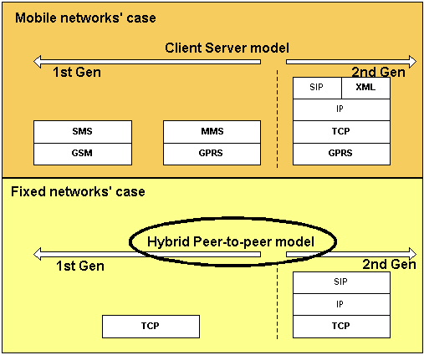
Source: IDATE

Technical and operating characteristics of the leading consumer IM solutions

Table 6: General description of the leading consumer instant messaging systems
Public instant messaging systems | IRC | MSN | ICQ | AOL | Jabber
General points
Architecture model | Client/Server | Client/Server | Hybrid P2P | Hybrid P2P | Client/Server
Proprietary IM protocol | No | Yes (MSNP) | Yes | Yes (OSCAR) | No (Open Source)
Protocols | TCP | TCP | TCP, UDP | TCP | TCP supporting XML, XMPP traffic
Messages | ASCII | UTF-8 (ASCII-compatible language) | ASCII | ASCII | ASCII
Control points
Existence of a buddy list | No | Yes | Yes | Yes | Yes
Place where user information stored | Server | Notification Servers | Central Server | BOS Servers | Client/Server
Server owners | Academics, volunteers | MSN | AOL | AOL | Jabber & Public
Presence of servers in France | Yes | No | No | No | Yes
Presence of servers in Europe | Yes | Na | Na | Yes | Yes
Source: IDATE

Table 7: General description of the leading consumer instant messaging clients’ functions
Public instant messaging systems | IRC | MSN | ICQ | AOL | Jabber
Client software, functions
Latest downloadable version | mIRC 6.1 | MSN Messenger 6.0 | ICQ Pro 2003 | AIM 5.2 | Jabber Messenger
Access to client software | Free download | Free download | Free download | Free download | Free download
Download address | irc.com; mirc.com | messenger.msn.com | icq.com | aol.fr/messager | jabber.com
Identifiers | Nickname | Nickname | UIN number | Screen name | Jabber ID
File exchange | Documents | Documents, audio & video files | Documents, audio & video files via UDP in client/server mode | Documents, audio & video files | Documents, audio & video files
VoIP | No | Yes  PC-to-PC & PC-to-Phone | Yes (ICQPhone)  PC-to-PC & PC-to-Phone² | Yes (AIMPhone)  PC-to-PC & PC-to-Phone² | Yes
Mobile connectivity | No | Yes | Yes | Yes | Yes
P2P exchange | No | Yes | Yes (message only) | Yes | Yes
Emoticons | No | Yes | Yes | Yes | Na
Interoperability | No | Sametime, Reuters | AIM | ICQ, Sametime | Sametime
Encryption option | No | Na | No | Yes | Yes
IM forwarding | No | Na | No | Yes | Yes
Message storage | No | Yes (but requires Internet Explorer v6) | Yes | Yes | Yes
Source: IDATE

Case of mobile networks

The implementation of client-server and hybrid peer-to-peer models in the case of mobile networks is conceptually identical to that of fixed-line networks. However, as the characteristics of these networks differ, some of the details vary significantly.

Instant messaging clients are not yet part of the standard software offering for major manufacturers’ mobile handsets. Operators therefore offer customers using mobile phones with an open OS (typically Java or Symbian at present) the ability to download these clients and then install them on their terminals. These clients are developed by third party producers. However, In view of the potential success of these services, major handset manufacturers will probably include IM client applications in their handset offers within the next year or two.

IM service users do not exchange messages written in TCP-based command languages. Three cases may arise:
- The messages sent/received are SMS messages
- The messages sent/received are XML streams
- The messages sent/received are SIP over IP streams.
Whatever the solution, these messages have a fixed price, which is charged to the customer on the basis of the price of SMS messages. Furthermore, certain value-added mobile services, such as location-based services for example, can provide IMing with enriched functionality.
Lastly, users access the IM service by registering with their operator in a centralised database. When this access is fee-paying, user authorization controls are carried out at the time of registration. IM service users are characterised by their phone /SIM card number.

Figure 9: Mobile networks' case, Client/Server model
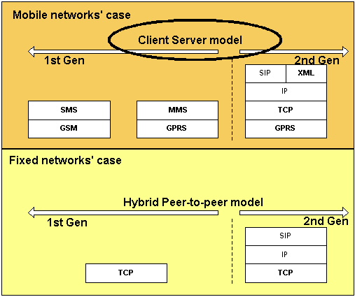
Source: IDATE

* *
*

Business models related to instant messaging services

Case of fixed service providers

Independent instant messaging service providers
The world’s leading service providers (MSN, AOL IM, Yahoo! IM) are positioned as providers of instant messaging services to the entire global online population. They develop their business model in the following value chain in this case:

Figure 10: Value chain of leading IM service providers
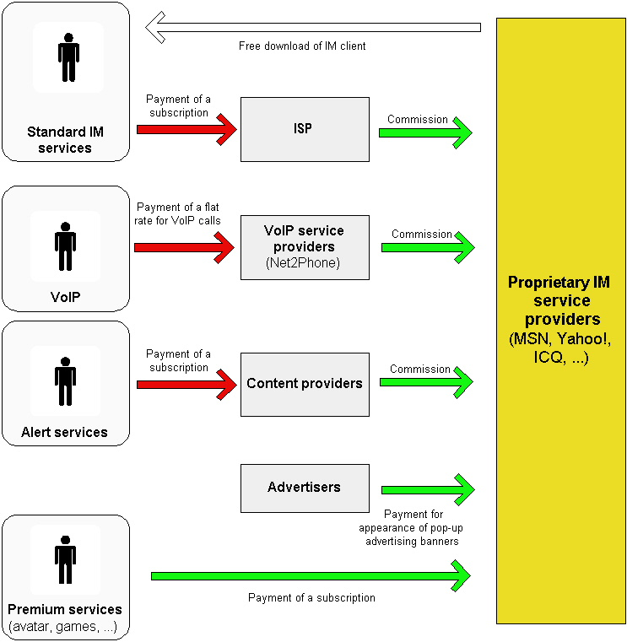
Source: IDATE

As we can see, the entire revenue-generation chain is indirect. It should nevertheless be noted that most of the time there is no form of revenue-sharing between the ISP and the IM service provider at present. In France, for instance, all the service providers offer end users their services free of charge, both directly and indirectly, on the basis of a market share acquisition logic.

Billing schemes adopted

As most instant messaging services are free, hardly any billing schemes have been implemented by solution providers. Some value-added services are for-pay in certain regions around the world, however, and can give us an idea of the conditions in which paid services could be deployed. There are two cases to envisage in this context, that of MSN Messenger in the United States and AOL Instant Messenging in the same country.

VoIP billing solutions

MSN Messenger offers users a list of voice service providers which deliver access to an internet telephony service for a pre-paid fee. Users wishing to use these services have to pay money (which can be deposited online) into a prepaid account and, in return, the provider offers a long distance call service for calls made using MSN Messenger.
Similarly, from version 4.1 of its client software onwards, AOL integrates a VoIP module in the American version of its client called AIMPhone, which it developed with PC-To-PC telephony specialist, Net2Phone. Access to the service is free, and there are no connection and service activation charges. Calls are billed on a per-minute basis: from 0.039 USD a minute for a national or Canada-bound call, and from 0.079 USD a minute for an international call. AOL bills customers for its services, either by charging them on their AOL ISP invoice if they have one, or on their bankers’ card.

Value-added service billing solutions

AOL offers non-AOL ISP subscribers using AIM subscriptions enabling them to download as many skins as they like ("AIM Expressions") from a dedicated site - www.aim-expressions.com - in order to personalise their software clients. AOL offers monthly subscription at 1.95 USD or an annual subscription at 9.95 USD. These subscriptions are charged to the users’ credit card, of which they will need to give the details.

.

Characteristics of the value chains established by independent instant messaging service providers

Table 8: General description of the leading consumer IM systems’ value chains
Instant messaging service providers | IRC | MSN | ICQ | AOL | Yahoo!
General points
Type of reference value chain | Entirely free | Service provider | Service provider | Service provider & ISP | Service provider
Subscription to service | No | No | No | No | No
Paid downloads | No | No | No | No | No
Sources of revenue | None | Advertising only
Primary source of advertising revenue |  | Sale of indirect advertising space related to the consultation of client software download sites
Secondary source of advertising revenue |  | Sale of direct advertising space related to the sale of banners on clients
Customisation services available
Existence of a buddy list | No | Yes | Yes | Yes | Yes
Customisable buddy list | No | Yes | Yes | Yes | Yes
Customisable user interface | No | Possible | Possible | Possible | Yes
Customisable messages (emoticons) | No | Yes | Yes | Yes | Possible
Source: IDATE

Table 9: General description of the leading consumer IM systems’ value chains
Public instant messaging systems | IRC | MSN | ICQ | AOL | Yahoo!
Functions and value-added services available
File exchange | Documents | Documents, audio & video files | Documents, audio & video files | Documents, audio & video files | Documents, audio & video files
VoIP | No | PC-to-PC in France | PC-to-PC in France | PC-to-PC in France | PC-to-PC in France
Mobile connectivity | No | Yes, on the basis of a surcharge on SMS sent by a mobile user and subscription to the notification service
P2P exchange | No | Yes | Yes (message only) | Yes | Yes
Video calls | No | Yes | Yes | Yes | Yes
Source: IDATE

ISPs offering instant messaging services

Pan-European ISPs generally use a proprietary instant messaging system in Europe. Nevertheless, it is important to note that users are free to choose their own client, independent of their ISP, except in the case of Tiscali.
Wanadoo has its own instant messaging tool, Le Messenger, which is also available on the Voilà portal. The service is available to both Wanadoo and non-Wanadoo subscribers. Its European rivals have not been outdone, however: T-Online’s TOM solution is available in all the countries in which the group has operations (particularly in France with Club-Internet). Lycos, the subsidiary of Spanish incumbent carrier Telefonica, launched its maiden proprietary instant messaging service, Anywhere IM, at the end of April 2003. Since then, it has developed a new version of IM using IBM’s Lotus Sametime, called Lycos Messenger, based on SIMPLE, notably enabling interoperablity with AIM and MSN.
Tiscali’s Tiscali Messenger solution is only available to Tiscali community members. Users are required to sign up to an internet access service provided by Tiscali’s ISP (PSTN or ADSL) in order to become a Tiscali community member.

Figure 11: 1st generation fixed IM services
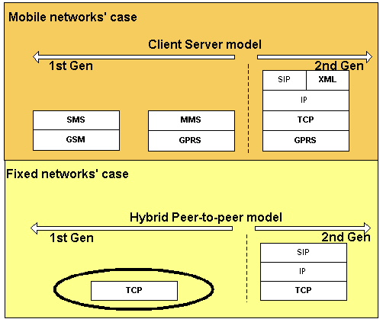
Source: IDATE

These companies aim to generate traffic and create a loyal subscriber base. ISPs can also persuade their subscribers to migrate to broadband offerings by pushing the technological possibilities associated with sending audio and video content. This has led them to place instant messaging at the heart of their community platform, structuring part of its community identity around the use of this kind of program. Certain ISPs therefore compare instant messaging to the phone service, email and the postal service.

Figure 12: Value chain of leading ISPs providing IM services
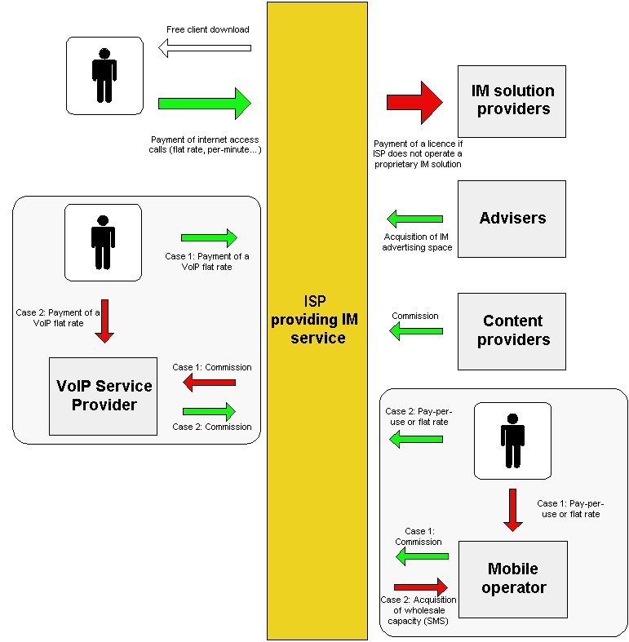
Source: IDATE

Characteristics of the value chains established by leading ISPs in the French market

Table 10: General description of the leading consumer IM systems’ value chains
Instant messaging service providers | AOL | Club Internet | Free | Tiscali | Wanadoo | 9 Telecom | Tele 2
General points
Name of client | AOL Instant Messaging | TOM | MSN Messenger | MESSAGER | le Messager | No offer | No offer
Accessibility | Free | Club-Internet subscription | Free | Tiscali subscription | Free | No offer | No offer
Web address for download | http ://aim.aol.fr/ | http ://www.club-internet.fr/rejoignezclubinternet/nos_services.phtml?rub=2#messagerie | http ://www.msn.fr/msger/msger_plus/default.asp?partner=free&Ath=t | http ://messager.communautes.tiscali.fr/ | http ://www.wanadoo.fr/bin/frame.cgi?service=communiquer&u=http ://messager.wanadoo.fr | No offer | No offer
Source of revenue | Advertisers | Contributes to subscriber base development | None | Contributes to subscriber base development | Contributes to subscriber base development | No offer | No offer
Customisation services available |  |  |  |  |  | No offer | No offer
Existence of a buddy list | Yes | Yes | Yes | Yes | Yes | No offer | No offer
Customisable buddy list | Yes | Yes | Yes | Yes | Yes | No offer | No offer
Customisable user interface | Possible | Possible | Possible | Possible | Possible | No offer | No offer
Customisable messages (emoticons) | Yes | No | Yes | Yes | Yes | No offer | No offer
Source: IDATE

Table 11: General description of the leading consumer IM systems’ value chains
Public instant messaging systems | AOL | Club Internet | Free | Tiscali | Wanadoo | 9 Telecom | Tele 2
Functions and value-added services available
File exchange
VoIP | PC-to-PC in France | PC-to-PC in France | Free | Tiscali subscription | Free | No offer | No offer
Mobile connectivity | Yes, on the basis of a surcharge on SMS sent by a mobile user and subscription to the notification service |  | Yes, on the basis of a surcharge on SMS sent by a mobile user and subscription to the notification service |  |  | No offer | No offer
P2P exchange
Video calls
Source: IDATE

The ISP’s instant messaging tool is viewed as a driver for attracting customers and persuading them to take out an ISP subscription. In this respect, ISPs often use the interoperability of their solutions with those of major independent service providers as a tool for distinguishing themselves from the competition.
Lastly, ISPs very often use instant messaging as a key marketing tool aimed at generating an advertising audience on their portal or attracting non-subscriber users.

Case of mobile service providers
Instant messaging services are far more complex in the mobile sphere than they are in the fixed arena because the message streams generated by user sessions have a value.
There are no real mobile instant messaging offers in France to date, but chat via SMS and WAP services do exist. These services constitute the beginnings of the development of instant messaging services in mobile operators’ offers.

Table 12: Description of mobile chat offers in France
 | Orange | SFR | Bouygues Telecom
Via SMS
Service registration | Free at 20123 | Free at 2428 | Free at 2424
Sending an SMS | 0.05 EUR per message sent + price of an SMS | Price of a normal SMS | 0.15 EUR per message sent or deduction of an SMS from an eventual SMS flat rate plan
Receiving an SMS | Free | Free | Free
Via WAP
Service registration | Free | Free | Free
Cost of using service | Usual Orange subscriber arrangements apply to payment of WAP calls | Price of a normal WAP call | 1 EUR for 24H – 3 EUR for 7 days
Cost of sending a WAP message on top of cost of using the service | 0.15 EUR | 0.14 EUR
Source: IDATE

Instant messaging services will most probably develop in mobile service user communities, firstly through the use of specific clients that can be downloaded to open OSes, generating a stream of messages priced on the basis of an “SMS equivalent”.
Other additional functions such as sending MMS messages and video streaming during an IM session could then gradually develop.

From a practical point of view, two types of services similar to instant messaging are currently available on the market. These services are mobile chat services and access to fixed IM services thanks to Java applications that can be downloaded onto mobile phones. These two cases are analysed below.

Mobile chat services
Two main business models can be found in the mobile chat services currently included in mobile operators’ service portfolio:
- The first model corresponds to the case where the service is offered by a service operator: the WASP (players such as Freever for mobile chat, or perhaps Jabber for mobile instant messaging in the future) has a specific agreement with the operator which generally includes:
  - a fixed licence payment for using the WASP’s applications
  - a variable, depending on the volume of calls generated by the service, for example.
- The second model corresponds to the case where the service is provided by an independent producer, on a kiosk like I-mode or Gallery, for instance; revenue-sharing is based on the kiosk rule, which determines the size of the commission that the operator needs to pay back the service producer.
Figure 13: Mobile chat services
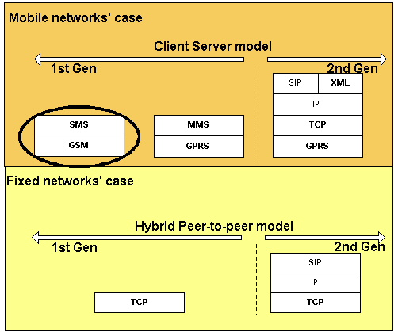
Source: IDATE

It is possible to combine these two models, as is the case with the company Freever, for example.

Figure 14: Value chain of mobile chat services
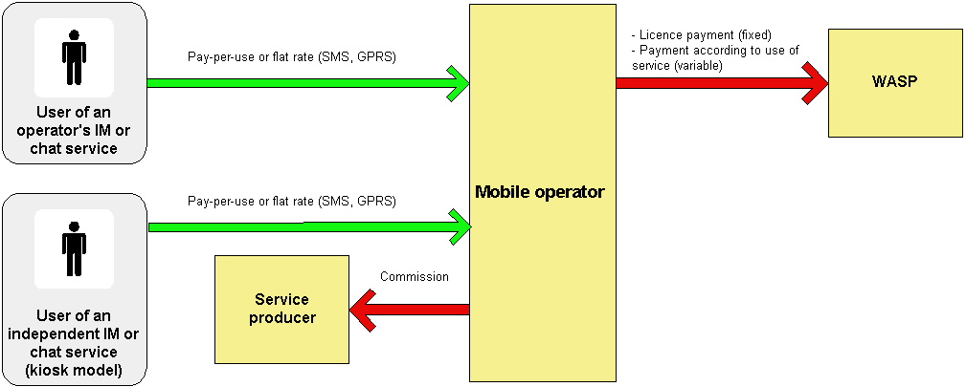

Source: IDATE

Access to fixed instant messaging services on mobile terminals (SMS, J2ME)

Services providing access to fixed instant messaging services via mobile handsets are now available in Europe via SMS (MSN, Yahoo!, AOL). The users of these services are able to install a downloadable Java application on their mobiles, for example, thanks to agreements between mobile operators and internet players. These applications allow users to send and receive messages to and from other users that have activated their client by sending and receiving SMSes.

Figure 15: Access to fixed instant messaging services on mobile terminals (SMS, J2ME)
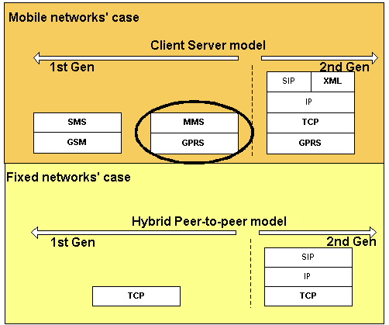
Source: IDATE

In this case, the most widespread model involves an operator receiving all of the revenue and paying back a portion of it to the fixed IM service provider to which users are connected via the Java application.

And lastly, a more unusual case is that of a fixed IM service provider purchasing a volume of SMSes wholesale, then charging the user directly. However, paying the service provider directly does not necessarily exclude paying the operator for usage (SMSes sent for example). This models therefore implies a direct billing relationship between the IM service provider and the end customer.

Figure 16: Value chain of access to fixed instant messaging services on mobile terminals (SMS, J2ME)

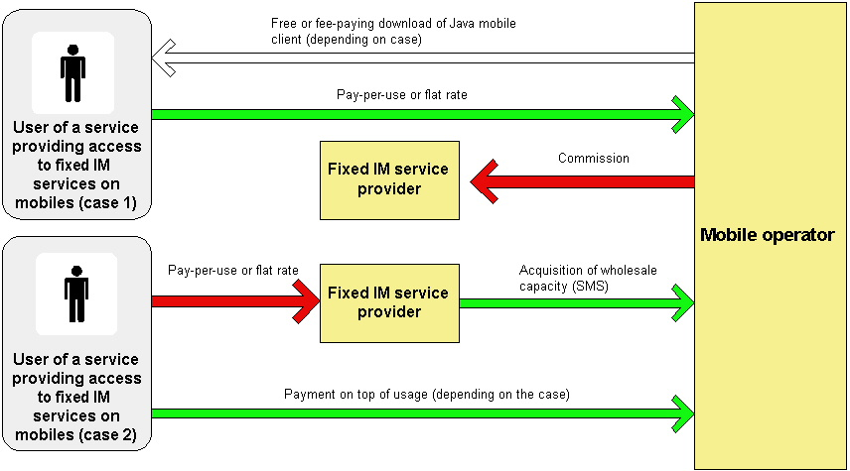

Source: IDATE

Conceivable value chain in the case of mobile instant messaging services

Even though these instant messaging services have not been launched in Europe yet, it is already possible to outline the major elements in the value chain that could establish itself when these services are introduced.
The launch of new generation IM services by mobile operators is dependent on the addition of "presence management servers" in network architecture. This is the element that makes it possible to manage the notion of presence in mobile networks. Furthermore, this equipment can be a medium for or a complement to other mobile services, especially those related to location-based services.

Certain operators’ projects to develop IM services include plans for interoperability with other national cellcos, and in certain cases, interoperability with fixed IM services.

Figure 17: Coming mobile IM services
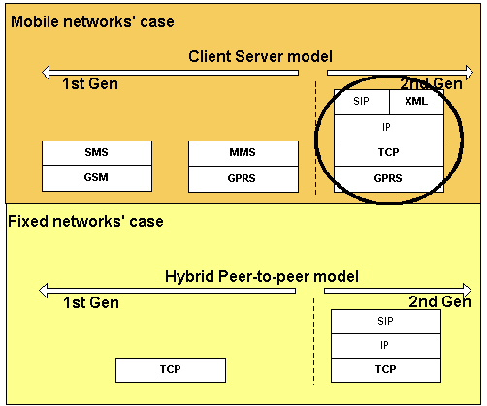
Source: IDATE

Clearing house schemes are already in place between mobile operators meaning that revenue-sharing mechanisms should operate in the same way as for other mobile services.
On the other hand, there are no interoperability ties between mobile operators and fixed IM service providers, meaning that pay back agreements will have to be established on a case-by-case basis. Difficulties may arise at this level depending on the pricing model adopted (pay-per-use, unlimited or limited flat rate).

Figure 18: Case of an instant messaging solution that interoperates with other mobile operators and / or fixed IM providers
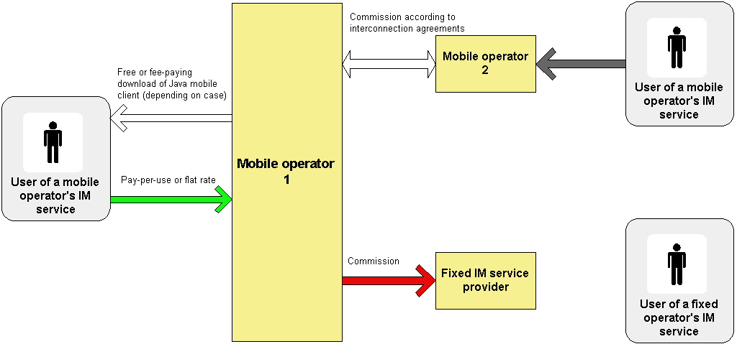

Source: IDATE

Examples of instant messaging services launched abroad

Lastly, mobile service operators have already included this type of service in some countries across the globe, occasionally in partnership with web instant messaging service providers. Two significant examples are described in detail below.

O2 Germany: mobile ICQ service
The mmO2 group has inked a deal with AOL to develop mobile versions of the ICQ and AOL Instant Messaging (AIM) applications in the various markets in which mmO2 is active.
O2’s German subsidiary (fourth largest operator in the German market) was the first to unveil a service when it launched a mobile version of ICQ in July 2003. mmO2 plans to launch a mobile version of AIM in Germany in autumn 2003. O2 UK should also be introducing mobile versions of ICQ and AIM this autumn.

O2 Germany’s ICQ service is available on the following handsets: Siemens M50, C55, S55 and Nokia 3650 and 7650. The operator’s (prepaid and postpaid) customers download the ICQ client onto their phone from the operator’s WAP portal. Messages are exchanged via GPRS.
The service is a mobile extension of the fixed ICQ service. Mobile service users therefore need to have registered previously as an ICQ user and the mobile application lets them interact with the entire ICQ community, as they would do from their fixed workstation.

Figure 19: Screenshots of O2 Germany’s ICQ service
Login page | ICQ buddy list on the Nokia 7650 | Sending a message
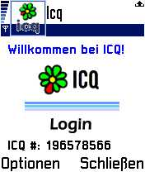 | 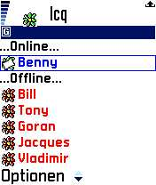 | 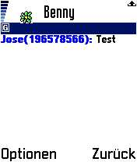
Source: O2 Germany

The price of the service for the end user is broken down into two parts, on the one hand, daily subscription costing 0.09 EUR/day and on the other hand, volumes of data exchanged via GPRS costing 0.05 EUR/10 Kb (rates apply until the end of December 2003).
An ICQ user with a smartphone appears online to other users once he/she has logged into the ICQ application, and until he/she leaves this application. Nevertheless, a mechanism enables the user to stay online whilst leaving the ICQ application to answer a call or to use an other application, for example. In this case, the ICQ server sends an SMS message to the user when he/she receives a message via ICQ, suggesting that he/she connects to ICQ again.

Vodafone UK and Orange UK: MSN Messenger by SMS
Vodafone UK and Orange UK offer their subscribers a number of MSN services. Together with these two operators, MSN provides a service delivering access to MSN Messenger via SMS. The basic principle of this service is that it allows users to receive and send messages when they are not connected to their PC. A list of commands also enables users to access their contacts’ connection status and to manage the buddy list.

If a user wishes to receive messages on his/her mobile phone, he/she must say so when exiting MSN Messenger on his/her PC:
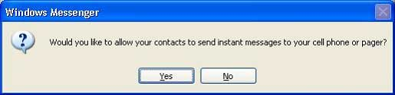
Source: Vodafone UK

The user uses simple commands to send a message. In the example below, the user sends the SMS with the message "1 Hello there" to send the text "Hello there" to contact number 1:

Figure 20: Sending a message

Source: Vodafone UK

The service can be accessed by all Vodafone UK and Orange UK subscribers who sigh up to it on the MSN website. Price details are given in the table below. The two operators have chosen to adopt the pay-as-you-go billing principle, charging for each message sent and received.

Table 13: Price of Vodafone UK’s and Orange UK’s services
Operator | Service price
Vodafone UK | 0.12 GBP for each message received and each message sent
Orange UK | 0.10 GBP for each message received and the price of each message sent depends on the price of an SMS in the subscriber’s rate plan
Source: IDATE, based on operator data

Solution providers offering corporate instant messaging services

In general, business solution providers develop proprietary solutions which they then sell to their customers. In most cases, they use partners to take care of installing these solutions in the enterprise’s local network.
In other cases, and particularly in the US, offers in “ASP mode” are developing, which allow businesses to outsource the management of software solutions associated with deploying an internal instant messaging service.

Figure 21: Value chain of instant messaging solutions in the business market

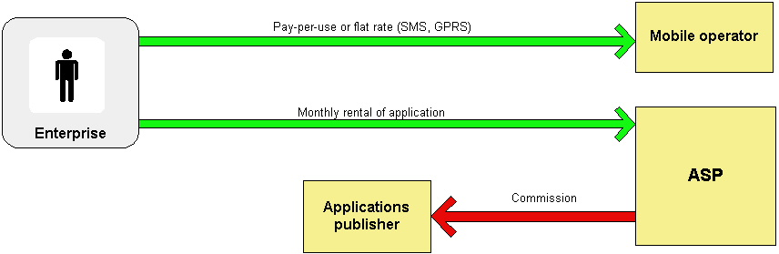

Source: IDATE

Here, the access infrastructure is fully transparent to the end user, who is able to access the service using his/her mobile handset thanks to the use of an embedded client or thanks to a client installed in his/her PC when the user accesses the service from his/her desktop.

The company pays the telecommunications flat rate plans corresponding to its access provider subscriptions (ISP, mobile fleet), and either buys the platforms enabling it to develop its services separately or rents them from an ASP.

Solutions deployed in the corporate world differ a great deal to those rolled out in the consumer service world, mainly on account of the constraints inherent to the business service market: necessity for employees to use secure messaging as well as the necessity to be able to store some of the messages exchanged.

Certain major business solution providers, such as AOL for example, use technical solutions developed by smaller-sized companies that are specialised in corporate instant messaging. Bantu, FaceTime communications and IMLogic appear to be the key players amongst these providers.

Bantu
Created in 1999, Bantu specialises in real-time communication and collaboration systems. Its solutions are based on a common platform, the Bantu IM & Presence Platform, and are geared towards enterprises, government organisations and the education sector.
The Bantu IM & Presence Platform solution is independent of the media platform used (the solution runs under Unix, Linux, Solaris and Windows 2000) and does not require users to download specific client software. Bantu offers a Java client that users can customise with its software development kit. Bantu’s solution interoperates with MSN, Yahoo! and AOL’s IM systems, in particular. It also offers a mobile solution called Bantu Mobile Messenger that is accessible via WAP.

Figure 22: Various Bantu IM clients
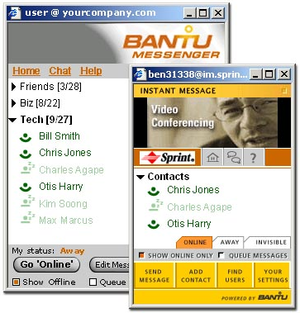

Source: Bantu
Bantu uses the SSL protocol for the various stages of the user authentication process and a proprietary technology for end-to-end message encryption. The US Army’s headquarters uses this proprietary technology for the 860,000 users of the Army Knowledge Online (AKO) portal.
Bantu markets its solution in two ways:
- Bantu Hosted: This solution is adapted to businesses that do not wish to deploy additional infrastructure in their LAN. Bantu hosts the IM service that it offers and sells it as a subscription. It is responsible for all the maintenance, repairs and optimisation of the service in the context of this offering. Bantu’s servers are centralised in an internet data centre in Sterling, USA.
- Bantu Installed: Bantu offers a version of its solution that is compatible with the Linux, Unix, Windows 2000 and Solaris environments and can be adapted to the various applications already installed in the enterprise’s IT system thanks to the development of specific APIs.

Customer example: Credit Suisse First Boston (CSFB)
Bantu has provided CSFB with an IM solution allowing CSFB’s customer managers to communicate in real time with their main institutional clients. Operating under the name CSFB Messenger, the Bantu IM & Presence Platform solution lets users exchange encrypted messages end-to-end, thereby complying with the SEC’s security rules concerning the security of electronic exchanges. CSFB Messenger is also compatible with MSN, Yahoo! and AOL’s IM systems. Bantu hosts all the exchanges generated by the communication system.

FaceTime Communications
FaceTime Communications is one of the leading providers of enterprise software enabling centralised deployment and management of real-time communication systems. The IM Director product line makes it possible to detect, control and manage use of the instant messaging and web chat service without having to change the company’s client software and servers. FaceTime has formed a host of partnerships with the leading public (AOL, MSN, Yahoo!) and enterprise (Lotus, Microsoft, Reuters, Communicator, Jabber) IM players, to this end.

Figure 23: Diagram showing the interoperability of FaceTime’s solution
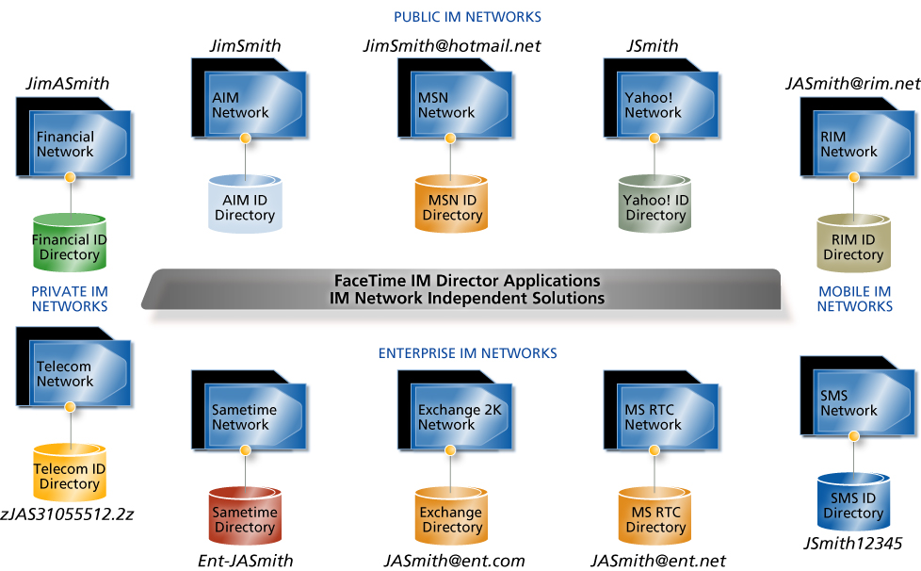

Source: FaceTime Communications

The IM Director solution range is based on an architecture supporting the HTTP and SIP/SIMPLE communication protocols and the XML/SOAP transfer protocols. IM Director makes it possible to keep tabs on a user’s actions by linking buddy names to the employees’ identities listed in the Microsoft Active Directory, Lotus Notes Domino, Sun ONE Directory Server and Novell Directory Server systems. The solution also includes a smart traffic management system that routes exchanges between employees in-house using a public IM client.

Figure 24: Architecture of the FaceTime IM Director Development Platform
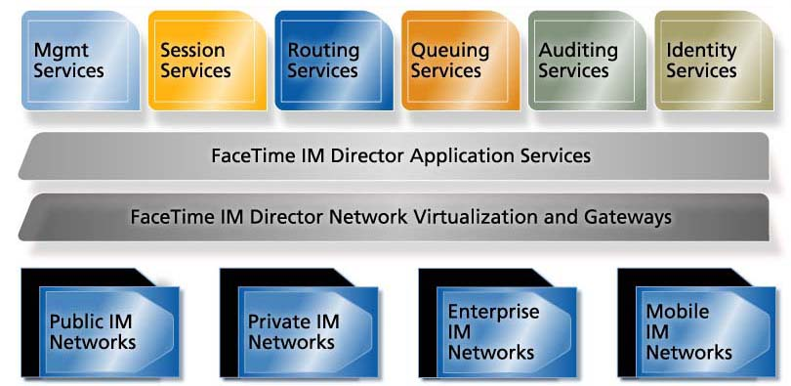

Source: FaceTime Communications

Customer example: Thomas Weisel Partners
The merchant bank Thomas Weisel Partners provides banking and investment services to institutional and private clients along with asset and capital management services. The company has equipped itself with the FaceTime IM Auditor solution in order to enable its brokers to communicate securely with clients in real time using MSN, AOL and Yahoo!’s leading public IM networks.

IMLogic
IMLogic competes directly with FaceTime Communications because it also provides software solutions making it possible to manage the connection of a business’ internal IM system to other existing IM systems (AOL Instant Messenger, MSN Messenger, Yahoo! Messenger, ICQ, Jabber, Microsoft Exchange 2000 IM, Lotus Sametime and Reuters Messaging).

Figure 25: General architecture of the IM Manager solution

Source: IMLogic

Synthesis

The various existing value chains in the fixed and mobile services spheres were implemented by players wishing to develop IM usage, in a context where usage was defined by a given access platform (fixed or mobile) and a given type of user community (consumers or corporate users).
These instant messaging services are starting to proliferate in 2003 and most market players are thinking about interoperability between platforms, and trying to look into the conditions in which they can break into service value chains established on platforms other than their own.

Towards the deployment of convergent services?

The deployment of fixed-mobile convergent (FMC) services has already been tested, particularly by MSN and AOL who have been offering services for sending messages to and from MSN users who use their mobile handset for this purpose for several years.
These initiatives have met with relative success at this stage, and have highlighted the key sticking points in fixed/mobile value chains:

- Fixed value chains are controlled by instant messaging service providers and mobile value chains are controlled by network operators. Mobile network operators actually control the entire access terminal distribution chain, but fixed operators do not.
- Fixed value chains are currently adapted to the “entirely free” model and mobile value chains are adapted to the “entirely fee-paying” model.
- The added value perceived by users in the fixed IM world is based on the enhancement of person-to-person communication offered by the service, and on availability in the case of mobile services. Fixed service providers charge for services that are “rich” in relation to their basic offers, whereas mobile service providers charge for access to the basic service and do not offer – for the moment at any rate – services enhanced with icons, video and voice calling services.

In view of these sticking points, it looks as though it will be difficult to superimpose value chains that are already established in the fixed and mobile worlds. The way revenue is generated, the principles of service provider payment and the principles of sharing player responsibilities differ in these two spheres, so it seems very unlikely that a single value chain will emerge in the fixed and mobile sectors in the short term.

Which change factors would allow fixed and mobile value chains to move closer together?

In the face of these two separate market structures, there are a number of factors which, by evolving, could bring players closer together on a more or less long-term basis.

Firstly, the widespread availability of “open” operating systems (Symbian devices, Java-type J2ME devices) should enable the emergence of developer communities that are sufficiently large to develop applications capable of recognising the standards used by the main services offered by IM providers in the fixed internet world.
These applications can generate TCP/IP streams with internet service operators’ content servers. The instant messaging client could collect TCP streams corresponding to messages in exactly the same way that it is possible to download emails onto a mobile phone in order to collect them.
Nevertheless, it is important to note that mobile operators could filter streams at the level of their GGSN using layer7 switch-type tools (switch on application layer of the OSI model) and therefore prevent these streams from accessing the public internet.

Secondly, the widespread availability of the SIP protocol for supporting real-time IP sessions could also be a factor that encourages the linking up of fixed and mobile players. This protocol supports 3GPP. services known as "IMS. It is therefore destined to support the development of value-added services in the context of UMTS networks as well. Consequently, this protocol will most probably enable optimum communication between equipment deployed by mobile and fixed service providers. De facto interoperability would easily be achieved in this context, and would no longer depend on commercial agreements between service providers, who would not have to bear the specific costs of establishing this interoperability.

More over the collaborative work environment is made synchronous by the use of instant messaging solutions instead of email solutions. For another thing, thanks to the use of web and object technologies for document sharing, this environment includes the ability to publish content enabling work sessions on one and the same document. Under this logic, the IM solution deployed within the enterprise will become an extended collaboration tool, obviously including text, but also offering the ability to establish SIP voice “sessions”, and to exchange files in peer-to-peer mode. By federating the main office tools through which business staff express themselves, this environment may allow instant messaging to become one of the most widely used communication services in the working world. Consequently, similar usage will be able to develop in the consumer services world.

* *
*

Service development prospects

Interoperability

Definition
The concept of interoperability in instant messaging services corresponds to an instant messaging client’s users’ ability to send and receive messages with people using other clients. This concept applies to both mobile and fixed.

What obstacles are service providers currently facing?

The main obstacles that services providers are currently facing are:

- First, the fact that there is no real demand for interoperability among instant messaging users who are currently using closed communities that have been built around the possibilities made available by the market’s leading services providers.
- Second, there is no “technical standard” in instant messaging. Most of the existing services use proprietary standards, most of which were developed by the service providers themselves. Opting for a single standard would force service providers to alter their own standards, something which can take place only gradually.
- Third, the business models that the market’s players have implemented are sometimes incompatible, notably in the case of fixed and mobile models.

The last two points allow us to define the issues to consider when contemplating solutions’ interoperability, and the fundamental elements that could make this interoperability possible.

Closed communities

Instant messaging is a communications tool that is viewed by advertisers and ISPs as the “cement” that binds closed communities.

From an historical standpoint, this notion of closed community appeared in the mobile world where, thanks to the application of an adapted rate policy, mobile operators were able to create this sense of “community.” Upon the launch of mobile operators’ offers, in fact, voice calls were generally billed at a better rate when an operator A subscriber called another operator A subscriber than when an operator A subscriber called an operator B subscriber.

This “club effect” helped attract a sizeable number of customers to the dominant operator, a community within which the majority of a user’s potential contacts were in the habit of gathering.

The development of instant messaging is part of a logic that is somewhat comparable. The lack of interoperability helps fuel the club effect between closed user communities. This club effect is highly beneficial to those providers with the largest subscriber bases (which makes them more appealing) and to those providers who have large subscriber bases that share a given feature (e.g. because they share German as a language, T-Online’s subscribers in Germany are naturally drawn to a service that has been designed and optimised for use with German).

These service providers’ marketing policy is therefore often to make instant messaging the cornerstone of their community by introducing value-added services that are only accessible, or accessible at preferred rates, to this user base.

In the same vein, for operating system or software providers, the growing use of instant messaging provides them with considerable leverage: instant messaging clients integrate the value-added features that use the software utilities which are part of these operating systems or applications, hence ensuring their distribution within the community of instant messaging service users.

By opening up the different communities that have been formed by the service providers, the development of interoperability between the market’s various clients destroys this club logic. In addition, it threatens certain business models that are based on this club logic, or threatens to converge the players’ different business models. Entirely free models could thereby emerge.

In the world of mobile services, however, interoperability between services is crucial, since they are subject to payment and made available by operators to their subscriber bases. In this case, interoperability between service providers does not necessarily imply convergence of business models which can remain distinct, while still being based on a pay-per-event logic that generates the service’s revenues.

Creation of a common standard for communication between instant messaging solutions’ addressing servers

SIP/SIMPLE in fixed services

Most of the leading instant messaging service providers use protocols that they themselves developed, which constitute the cornerstone of their service’s development and which are therefore incompatible with their competitors’. If one of these solutions were to be chosen as the universal standard, this solution’s intellectual property could not be shared and would naturally generate added costs for those using the standard (licensing fees). Added to this, the service provider who wrote the solution’s code would enjoy a greater ability, at least in the beginning, to add new features to the instant messaging solution’s interface.

To deal with these constraints, as part of public and private initiatives, notably the IETF, the industry has contemplated several solutions. These initiatives led to the development of the SIP/SIMPLE standard, which Microsoft has built into its Windows Messenger solution and IBM into its Lotus Sametime solution.

The IETF (Internet Engineering Task Force) is a working group devoted to the possible applications of SIP (Session Initiation Protocol) in the areas of instant messaging and presence. This group designed a standard that guarantees the interoperability of these services in line with the recommendations contained in the RFC 2779 and CPIM (Common Presence and Instant Messaging) specifications.

One of the prime features of SIP and SIMPLE makes it possible, when initiating a session between client and server, to define the nature of the stream that will be exchanged, and to supply the server with data on the client’s presence when the session is launched. It is therefore possible with SIP/SIMPLE, using a protocol standardised by the IETF and on standard hardware, to develop instant messaging tools that are capable of processing all types of media streams.

Wireless Village in the mobile service world

In the same way that the IETF is focused on the web, OMA, as part of the Wireless Village initiative, has developed specifications for an architecture adapted to the world of mobile services, and which includes a number of specific functionalities, most notably:

- The integration of a service user localisation feature, which makes it possible to exploit a more advanced notion of presence than for fixed web services, combining availability and proximity;

- The integration of specifications for handsets’ embedded clients which, given their functional characteristics, are not comparable to a PC’s characteristics;

- The inclusion of intra-cell roaming and the session continuity required for service execution continuity.

Openwave, Nokia, and Ericsson have all announced their support for these specifications and report that they will include these features in their products’ development plans.

Both of these initiatives have enjoyed widespread support from these two very different industries between which there currently exist very few gateways. Their goal is to support the interoperability of systems in the areas of fixed and mobile, respectively, and to allow the two sectors’ service providers to build solutions based on interoperable-ready software. What remains is for each of them to devise a viable business model based on open solutions.

Creation of clients compatible with the various existing standards

A great many service providers have developed clients that are capable of using the server resources that have been deployed by the market’s leaders (AOL, MSN, Yahoo!) and which therefore allow their users to hold conversations with different platforms’ users. Among the most prominent in this area are the following:

Trillian

Trillian is an instant messaging client geared to fixed networks, which was developed by the firm Cerulean Studios, based in Connecticut in the US. The first version of Trillian was created in 1998, and focused on a single goal from the outset, namely to allow instant messaging service users to have access to IM independently of the market’s leading providers, which were already AOL, MSN and Yahoo!. The concept is relatively simple: it involves emulating each type of client, at the TCP sent/received level, by using security holes in the major solutions’ addressing servers.
Figure 26: Trillian user interface
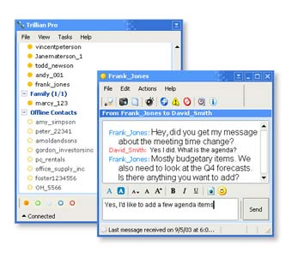

Source: Trillian

Thus, on 1 July 2000, version 1.0 of Trillian was released, and was interoperable with IRC. By 29 November of that same year, Trillian was also compatible with AIM and MSN and, in 2001, with Yahoo!. In 2003, Trillian was marketing two product offers: Trillian basic, which is a simple instant messaging utility with no security and few interfaces, which makes it possible to include advertising messages, and Trillian Pro. Trillian Pro is licensed for 25 USD and includes additional features that enable greater access to AOL, MSN and Yahoo! addressing servers, as well as Jabber xml plug-ins. Trillian Pro is stripped of all interfaces that allow advertising messages.

Odigo

Odigo is another instant messaging client which, like Trillian, was developed in the early 2000s with the goal of facilitating access to the many contact-server lists developed by the market’s major player (AOL, MSN and Yahoo!). Odigo solutions are therefore interoperable with ICQ, AIM, MSN Messenger and Yahoo! Messenger.

Figure 27: Odigo user interface

Source: Odigo

Odigo differs from Trillian, however, by the variety in its product portfolio which includes IM servers, IM-SMS gateways and management presence solutions. In May 2002, Odigo was taken over by Comverse. Since then, based on the Odigo client, a number of additional interfaces adapted to mobile services have been developed: portage on OS Windows CE, Web, J2ME, BREW, Palm, Blackberry, iMode and Symbian.
Odigo solutions can now in fact be ported onto any environment, and can allow these environments’ users to have access to all of the solutions offered by the market’s leading providers.

Jabber Inc.

The Jabber Inc instant messaging solution is composed of three elements:
- The XCP (eXtensible Communications Platform) which is based on a client/server architecture and uses the XMPP based on XML. The XCP is made up of a central server and a software suite (Jabber Directory Suite) that supports LDAP, an Oracle database component.
- Jabber Messenger is client software for workstations.
- Jabber WebClient is software that lets Jabber users have access to their IM service using a standard web browser.
In the 4th quarter of 2003, Jabber began marketing mobile extensions, including an XMPP mobile client that is compatible with the J2ME, Symbian, PocketPC, RIM Blackberry and Palm platforms. The other mobile clients (SMS, WAP, Wireless Village) will also be supported thanks to the development of modules integrated into the gateway and which use XCP Connection Manager architecture.
Jabber markets solutions to businesses and to fixed and mobile operators. Jabber Inc has some one hundred commercial agreements with companies and operators. Among the platform’s client operators are France Telecom and American ISP BellSouth which offers Jabber’s IM solution to close to one million customers.
Jabber markets its solution under a licensing model based on the number of user devices/workstations. In addition to its solution, Jabber Inc offers consulting services, software development, customisation, installation, support and training.

The creation of clients that use different standards allows users to have access to contacts whose features are housed on proprietary servers.
This type of interoperability is contingent on the ability to access the content on these servers, a process which is generally made possible through the use of security holes in the TCP layer on providers’ servers. Consequently, as was the case with Yahoo! in October 2003, the server’s owner can elect to “shut down” its solutions’ interoperability by working to repair these security holes, and forbidding the third party provider from taking advantage of them.

Conclusion: what will drive interoperability between services?

Regardless of the methods used to achieve it, interoperability of instant messaging solutions is possible, but remains difficult to put into play in the short term, from both an economic and technical standpoint. The instant messaging market does not appear to be mature enough for this to be contemplated in the near future, requiring major changes in the players’ strategy, who themselves are more inclined to seek to draw potential new customers over to their platform and perpetuate the club effect within a closed community.

Because of this, there is currently very little difference between the players, all of whom offer the same value-added features and do not really attempt to distinguish themselves from the competition.
Under this logic, the drive to foster the maximum club effect means that the market’s various service providers are not compelled to seek the interoperability of their platforms, the appeal of their service deriving from the number of regular users who access it.

On the user side of things, while it is invariably viewed as an advantage for a communication service, the need for interoperability is not currently a point of consensus, except within a handful of specific communities such as the financial community. On the consumer side, the success of clients that enable interoperability is real, but the success of interoperability itself is not. Service providers can still, in practice, close off access to their service to certain client providers (such as Yahoo! did with Trillian in October 2003).

The interoperability of different instant messaging solutions is therefore still today far from being easily achieved. Added to this, the need for interoperability is currently a demand only in some communities that use instant messaging a great deal. A trend towards interoperability nevertheless seems much more natural in the mobile telephony sector.
Interoperability between all solutions would therefore appear to be part of the expected developments of instant messaging services, but in a relatively distant future, in line with the effective and real widespread use of this type of solution.

Voice over IP and Video over IP services

The main value-added services offered by fixed instant messaging providers are Voice over IP (VoIP) and Video over IP. These two services allow instant messaging solution users to communicate in real time in voice and video mode, respectively.
Using a PC plug-in, instant messaging clients can encrypt the stream captured by the customer, using a microphone plugged into the computer or, for video, a webcam that is also plugged into the computer.
These streams, which are encrypted into standard formats (H323 or SIP for voice, for instance) are then managed by the IP network to which the user is connected, then made accessible to the recipient customer who may or may not be an instant messaging service user.

As it stands, a great many instant messaging solutions incorporate PC-to-PC, or PC to fixed or mobile phone, telephony over IP features. In most cases, the VoIP service provider (such as Primus or Net2Phone) operates pay back agreements with the IM solution provider so that payment for the IP communications is made directly by the user (Case 1 in the diagram below).

Figure 28: The VoIP service provider value chain

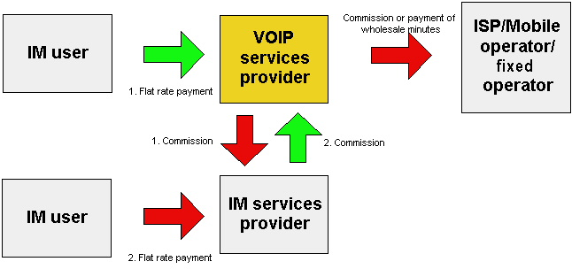
Source: IDATE

Nevertheless, VoIP services via IM clients do not yet ensure full continuity of service with PSTN or mobile subscribers since phone subscriber have no visibility of VoIP users. The call can only be initiated in the fixed IP environment, the call going out to PSTN or mobile phone subscribers. This one-sided call initiation constraint is one of the service’s prime limitations.

In France, no VoIP service has yet been integrated into a localised French language instant messaging client. In the US, however, most of the latest versions of the major providers’ instant messaging clients, which were available for download at the end 2003, included a dedicated VoIP interface with associated services.

These clients are however available for download in France.
Characteristics of the offers available on the American market

The leading IM providers on the American market offer real-time voice and video calling services. These services are sometimes operated directly (when the call is between two users of the same client) and sometimes with partners (notably in cases where the call termination is not another computer but a telecom device).

MSN

MSN Messenger integrates a VoIP function that enables PC-to-phone and PC-to-PC calls, provided that both users are equipped with at least version 4.5 of MSN Messenger. MSN Messenger offers users a list of voice service providers who market access to a paid internet telephony service.

Users can deposit money to an account that is managed by the VoIP service provider and, in return, the provider supplies a long distance calling service for all calls made through MSN Messenger. MSN’s main service provider partner is Primus with its PrimusTalk service.

MSN Messenger 6.0, Microsoft’s latest instant messaging client, includes a telephony over IP feature that uses the .NET Voice Service proprietary platform. This initiative marks a significant shift in Microsoft’s strategy by including features at the application solutions level that were previously operated by third party providers.

Figure 29: MSN Messenger 6.0 telephony over IP interface
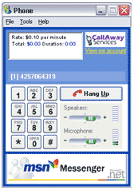
Source: MSN Messenger

With MSN Messenger 6.0, Microsoft MSN becomes, in appearance, its clients’ VoIP service provider, by using .NET Voice Services. Even though MSN does not thereby really become a VoIP service operator, Microsoft nevertheless controls collection of the revenues associated with this service, as well as its clients’ features.

In version 6 of its client MSN has also introduced person-to-person video calling features.

AOL Instant Messenger

Since version 4.1 of its client software, AOL has included in the American version a VoIP module called AIMPhone, which was developed with PC-to-PC telephony specialist Net2Phone. Access to the service is free; there are no service connection or activation costs. Billing for calls is by the minute, starting at 0.039 USD a minute for a national call, or a call to Canada, and starting at 0.079 USD a minute for an international call.

Figure 30: The AIMPhone Interface
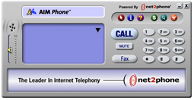

Source: http://aimphone.aol.com/pc/

Like with MSN, collection of revenues associated with these VoIP services is performed by AOL which outsources access to network resources to an exclusive partner, namely Net2Phone.

On 8 August 2003, the FCC authorised AOL to integrate video-telephony and web conferencing features into its AIM client. The company had previously been forced to limit its development in this area, because of the AOL-Time Warner merger.

Yahoo!

Yahoo! introduced VoIP services early on, back in February 2000. At the time, Yahoo! Messenger’s offer incorporated access to Net2Phone’s long distance calling features.
These services are no longer available, and have been replaced by webconferencing services, operated by Yahoo! and which use IP stream generation on the TCP 5010 port.

Instant messaging versus VoIP

Voice over IP services that are offered on instant messaging clients allow users to communicate with one another through their computers, but not longer by having to type their words on a keyboard. In this sense, the services are designed to expand the personal communication experience by allowing users to interact in an even more intimate way.

In many respects, the services offered by instant messaging service providers are similar to telephone services:

- The communication between users is not stored nor archived, unlike e-mail, for instance.
- Communication between users is established in an intrusive fashion: once activated, the instant messaging client to which the user has logged on will open a window on the computer user’s screen and display a message that has been sent to him/her, regardless of the applications that are running at the time. In the same way, if a customer’s phone is activated, an incoming call is signalled by a ringtone, regardless of the work environment.

The similarities between voice telephone services and instant messaging text services have led a number of observers to predict that a potential convergence of the two could well come to pass at some point in the future.

In this respect, the instant messaging interface allows a computer user to access VoIP services under much better conditions than with other clients that enable access to VoIP services:

- No downloading, installation or configuration of a specific utility is required;

- A search for a correspondent’s address is neither required, nor difficult, since their address corresponds to their name on the user’s buddy list.

- The problem of the correspondent’s availability is non-existent since, if the user being called is active on the buddy list, he/she is inevitably sitting at his/her computer, and can therefore notify the instant messaging service provider whether or not he/she is accepting incoming voice calls;

- Lastly, leaving a message for someone who is not logged on, or refusal to communicate with someone, in text mode, is easy. Even if someone is not logged on, most instant messaging platforms, if the recipient users agrees, can forward incoming instant messages to the recipient’s e-mail box (IM-forwarding feature).

Conclusion: long term prospects for VoIP and Video over IP services

The deployment of VoIP or Video over IP services as part of instant messaging clients is already a reality, and the market’s leading players all offer these features, particularly in the US. These services are currently available for free to users who subscribe only to MSN, AOL or Yahoo! resources in the US. These features are not always available in France, in large part because the penetration rate of instant messaging services among consumers is lower than in the United States, hence the market’s players are not seeking to distinguish themselves from the competition through their services.

As it stands, all voice-oriented solutions providers offer free PC-to-PC voice services, and free PC-to-PC video calling services. This free model nevertheless hides specific restrictions that these service providers face:
- The need to go through a third party provider who can ensure long distance calls, and interconnection with the fixed or mobile phone network for local calls,
- The need too for video service users to be equipped with a broadband connection to the internet, which is the only way to guarantee a quality of service in line with the goals of the service providers operating in the field.

Person-to-person communication services based on instant messaging, on the other hand, mark a significant development over more classic person-to-person communication services, most notably:

- In terms of their ability to be personalised by the user, along with the ability to personalise the communication itself (emoticons, interfaces, buddy lists, group calling, etc…).
- In terms of the integration of their features into other communication tools: Outlook 2003, for instance, constitutes a joint interface between email and IM. To this can be added VoIP Calling and Video Calling, using the same address book/buddy list.
- By facilitating access to VoIP services thanks to a utility that manages the call establishment and referencing features.

Here, then, instant messaging constitutes a tool that enables easy access to Voice over IP services, by providing users with easy access to the tools. This ease of use, combined with increasing integration of messaging tools from the leading desktop software suites, make instant messaging services the first computer platform that enables management of a convergent communication platform that combines voice, text and video.

Peer-to-peer

In their latest versions, most of the major solutions that are available on the market have included a feature that allows peer-to-peer file swaps between users of the same service.
These features were introduced to allow users to share photos and personal files, although nothing prevents a user from exchanging files with his/her buddy list, even if they are protected by copyright laws.

P2P functions that are part of instant messaging solutions are not, however, comparable to those found on systems like Gnutella or Kazaa, which scan the web in search of other similar, open file sharing systems. In the case of instant messaging solutions, there does not yet exist any automatic peered file detection features, nor a utility that seeks to perform an inventory, nor even a mass downloading tool. Here, instant messaging tools do not, at least in the short term, represent a comparable threat to the content industry.

Nevertheless, we are beginning to see solutions based on the peer-to-peer model appear on the market, and which require the deployment of a server solution, hosted by the service provider and which therefore “controls” the system’s user base. This type of VoIP solution marks a veritable break with fixed IP systems, offering VoIP services that are built into their messaging clients, since calls exchanged between VoIP solution users in peer-to-peer mode is free.
This solution was developed by the firm, Skype.

Skype

Skype presents itself as a P2P phone company. The company’s goal is "to bring communications into the 21st century, challenge the outdated business models and rip-off tactics of legacy telecom companies and to bring global unmetered communications to people all over the world".

This ambitious programme was established by Skype’s two founders, who also founded Kazaa: Niklas Zennström and Janus Friis. The Beta version of Skype, which is currently available for free download, has already been downloaded over 1,425,091 times.

Figure 31: Skype interface
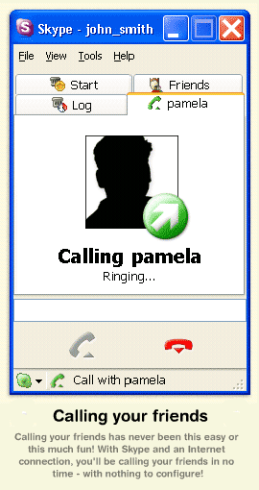
Source: Skype
The concept of Skype is simple: the application uses a peer-to-peer engine similar to Kazaa’s or Napster’s, but is geared to establishing peer-to-peer sessions between Skype users. Because of this, the voice calls offered by Skype cannot be made to anyone outside the Skype community. Skype uses FastTrack technology which was already used as a cornerstone of the solutions developed by Kazaa. Rather than dedicating a connection’s bandwidth to supernodes, however, in order to maximize access to a body of peered files, Skype uses the same bandwidth resources to enable encryption of streams that support more complete audio/video compression techniques, along with dynamic allocation of these resources to route IP streams between peers in the most efficient way possible.
The resulting technical output of these solutions is a quality that is entirely comparable to the solutions marketed by Net2Phone or Primus.

Figure 32: Skype's VoIP service compared to those provided by other VoIP specialists or IM services providers
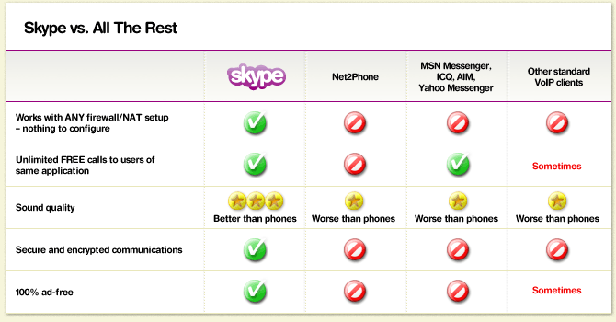

Source: Skype company

The features embedded in Skype are still relatively limited: they do not include technical support for audio compression, for instance, nor any conferencing functions. In the same vein, Skype does not enable calls to fixed or mobiles phones. These last two features are, however, expected to be included in future versions of Skype.

Conclusion: long term prospects for the development of P2P solutions

The introduction and development of solutions like Skype is highly significant as it alters the notion of telecommunications operator by making the process fully electronic. The features of Skype users are not centralised in a hosting centre, but rather stored in Skype clients, with a three-day lifespan on the availability of peers who have not re-opened their clients.

This means that the notion of “subscriber control” becomes non-existent, since the service is not centralised, and that there are no subscriptions, per se. The telephone service operator disappears, only an IP bandwidth provider remains (the ISP), and a provider of interconnection between the fixed and mobile networks.

Although it is still difficult to use Skype across a body of NAT gateways, firewalls and data protection software tools, it is nevertheless important to consider the fact that these solutions can be transmitted at the same speed as P2P solutions that offer file exchange features, and to the same population of users. Because of this, it is entirely likely that the user population in France, for instance, will soon exceed one million.

* *
*

Annexes

Annex 1: Acronyms and definitions

Acronyms | Definitions
ASCII | American Standard Code for Information Interchange, a character encoding system developed by the American National Standards Institute (ANSI).
ASP | Application Service Provider.
ATM | Asynchronous Transfer Mode.
CDMA | Code-Division Multiple Access, multiplexing technique used in the mobile telephone industry.
FTP | File Transfer Protocol, used on the internet for transferring files.
GGSN | Gateway GPRS Support Node, gateway between a mobile network’s core packet network and the external packet-switching network (public internet, private intranet, etc.)
GPRS | General Packet Radio Service, broadband mobile telephony standard that reaches a speed of 150 kbps.
GSM | Groupe Spécial Mobile or Groupe Système Mobile. Second-generation mobile telephony standard.
H323 | Voice compression technique.
HTTP | HyperText Transfert Protocol, communication mode used on the web between the client software (browser) and the server (the one that provides the page).
IP | Internet Protocol, internet-based data transport protocol allowing data packets called datagrams to be routed between nodes in a meshed network.
ISP | Internet Access Provider.
J2ME | Java 2 Micro Edition, an edition for Java mobile terminals.
LAN | Local Area Network.
MMS | Multimedia Messaging Service, evolution of SMS enabling the exchange of multimedia content (image, sound, video).
OS | Operating System.
OSCAR | Open System for Communication in Realtime, AOL’s proprietary protocol used for official AIM clients.
PSTN | Public Switched Telephone Network.
SAP | Service Access Point.
SIP | Session Initiation Protocol, voice-oriented IP protocol destined to replace H323. SIP is the medium for calls made over IP in the UMTS R5 standard.
SMS | Short Message Service, a short telephony-based text message service.
SMTP | Simple Mail Transfer Protocol, a protocol used for transferring email on the internet.

Acronyms | Definitions
SOAP | Simple Object Access Protocol, proposed by Microsoft in the IETF as part of its .NET initiative.
SSL | Secure Socket Layer, protocol used for secure payment aimed at protecting the transmission of sensitive data.
TCP | Transport Control Protocol, TCP establishes and controls a momentary link between a machine transmitting IP data packets and a machine to which the packets are destined.
TLS | Transport Layer Security is a protocol emanating from an IETF project based on v3 of SSL and intended to ensure greater confidentiality of communication on the web.
TOC | Talk to OSCAR, a light TCP-based OSCAR used for developing third party clients.
UDP | User Datagram Protocol, a transport protocol for which there is no guaranteed message delivery and no sequencing.
UMTS | Universal Mobile Telecommunications System, the third generation mobile telephony system.
UTF-8 | Universal character code intended to gradually replace the ASCII code.
VoIP | Voice over IP.
WAP | Wireless Application Protocol, a protocol enabling mobile phones and PDAs to use different internet services without calling on numerous resources.
WASP | Wireless Application Service Provider.
XML | eXtensible Mark-up Language, a document description language standardised by the W3C.
XMPP | eXtensible Message and Presence Protocol, an open XML-based IETF standard enabling XML elements to be delivered in near real-time.
Source: IDATE

Annex 2: List of interviewed companies

AOL | Jabber Inc.
BETC | MSN France
Bouygues Telecom | Nokia
Club Internet | Openwave
Comverse | Orange
Free Telecom | Reuters
Freever | SFR
Hewlett Packard | Wanadoo
IBM Lotus Sametime | Yahoo!
IETF SIP/SIMPLE

IM: Throughout this document, IM will denote "instant messaging" in all its forms.
The MSNP7 version of the protocol corresponding to version 4.7 of the MSN Messenger client
Version 5 of the protocol
Version 2001 of the OSCAR protocol
April 2003 version
Buddy list: a list of contacts or service users that is available when using a client. Most fixed instant messaging solutions let users manage their own buddy lists via the client by indexing contacts by topics, centres of interest, type of community (friends, family, etc.) and managing them themselves.
IM services sometimes offer integrated functionality in their clients enabling two users to establish a voice chat session.
PC-to-Phone abroad only (service available in the United States notably).
Denotes fixed IM clients’ capacity to offer services for sending and receiving messages to mobile users.
Denotes IM clients’ capacity to offer service users file sharing functionality in P2P mode.
Emoticons are icons that client users are able to use to personalise their message titles, according to the content or to their mood at that particular moment, etc.
Interoperability should be taken to mean a solution’s capacity to communicate with another solution’s users in this table.
Characterises the ability to forward messages, which implies temporary storage on the PC where the client is used.
Wireless Application Service Provider.
Description available on http ://www.msn.co.uk/msnmobile/vodafone/mobilemessenger/ for Vodafone UK and on http ://www.msn.co.uk/msnmobile/Orange/ for Orange UK.
3G Partnership Project, standard body for UMTS
IP Multimedia Subsystem

